**Assignment 17.2**

Problem Statement 1

1) Read the text file, and create a tupled rdd.

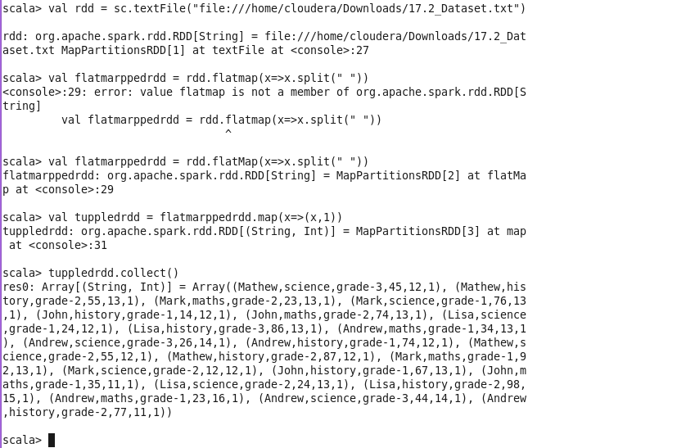

2) Total number of rows preset

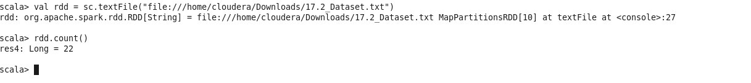

4)

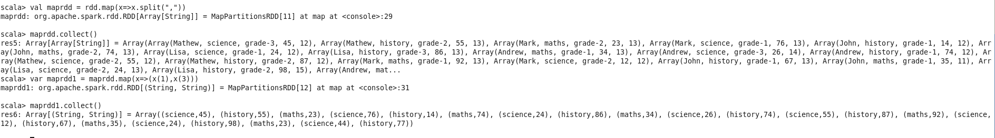

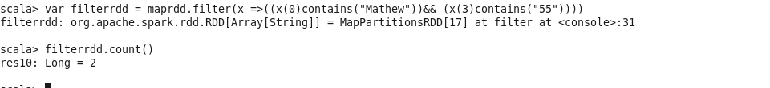

Problem statement 2

1)

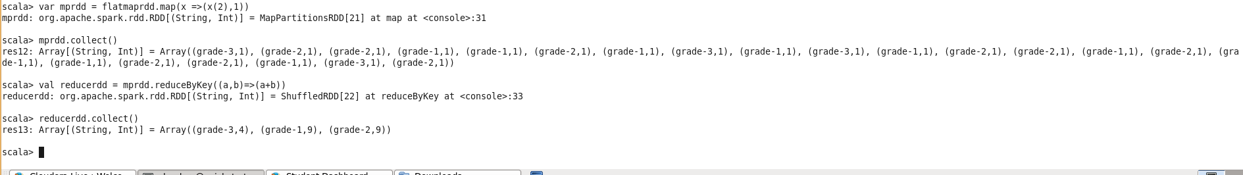

2)